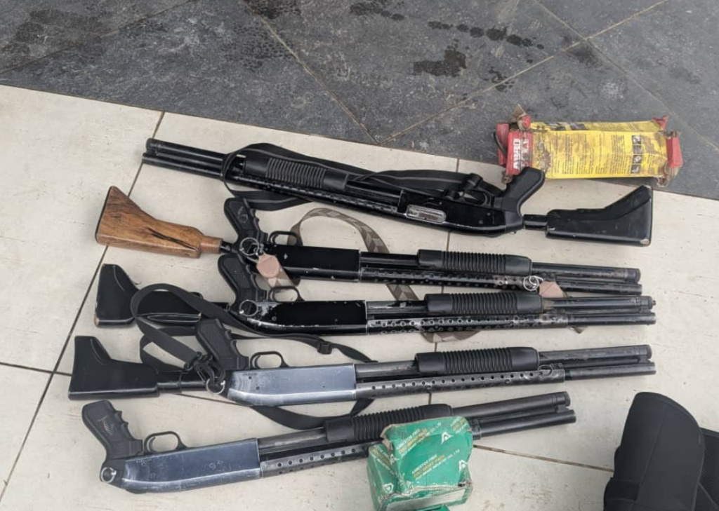
GUNS & BLOOD ROCK CHRISTO ASAFO!
…Apostle Kwadwo Safo’s legacy threatened by internal strife, strife & legal cases
The legacy of Apostle Kwadwo Safo, who died recently, has been rocked by news of internecine strife within the church he used decades to build and left behind recently.
Sections of his children seem to be warring over who succeeds him as the leader of the church. And as at Sunday, one of his favorite children, Sarah Adwoa Safo, had to be rushed to a hospital for emergency care after she was struck in the head by what many claim is a bullet fired by one of the bodyguards of her brother, Mr. Tamakloe Safo Jehoshaphat, also known as Akofena, also known as Israel Kwadwo Safo or Nana Kwadwo Safo Akofena.
However, even before the guns and shooting on Sunday, the leadership succession dispute within the Kristo Asafo Mission of Ghana had landed in the High Court in Accra, with two senior members of the church seeking to stop the planned installation and recognition of a successor to the late founder, Apostle Kwadwo Safo.
The suit filed on Friday, June 19, at the General Jurisdiction Division of the High Court in Accra, challenges the eligibility of Israel Kwadwo Safo (Nana Kwadwo Safo Akofena) to assume the office of leader of the church following the death of the renowned inventor and industrialist in September last year.
The plaintiffs, Kweku Agyenim Boateng, a former Deputy General Secretary of the church, and Seth Appiah Richard Brown, a long-serving member and former Executive Assistant to the church leader, contend that the proposed succession process violates the constitution governing the church.
Named as defendants in the suit are the Kristo Asafo Mission of Ghana, Israel Kwadwo Safo, Festus Owusu Badu, Dr Kwadwo Addo Oduro and Robert Ntiful.
The action seeks a number of declarations and injunctions aimed at preventing the installation, presentation, recognition or holding out of the second defendant as leader of the church.
Plaintiffs' argument
According to the statement of claim, the Kristo Asafo Mission is governed by a constitution originally established in 2017 and subsequently amended in 2024, which the plaintiffs argue constitutes the supreme law regulating the affairs of the church.
The plaintiffs state that after the death of Apostle Kwadwo Safo in September 2025, questions emerged regarding the lawful succession to the leadership of the church.
They argue that under Article 26(1)(a) of the church's constitution, a successor must be appointed within three calendar months of the leader's death and that specific constitutional provisions govern who may legitimately succeed to the office.
While acknowledging that the late founder had at one point designated the second defendant as his successor under an earlier constitutional framework, the plaintiffs contend that amendments made to the church's constitution in 2024 altered the succession arrangement and effectively removed him from the line of succession.
The suit further claims that the 2024 constitutional amendment represented the final and deliberate wishes of the late founder regarding succession to the leadership of the church.
Planned installation challenged
According to court documents, the plaintiffs allege that despite the constitutional changes, efforts are being made to install, present and recognise the second defendant as leader of the Kristo Asafo Mission.
They further claim to have become aware of plans for a public ceremony intended to formalise that installation.
The plaintiffs argue that any such installation or recognition would be unlawful, null and void because it would be inconsistent with the church's constitution.
They further contend that the intended installation has generated uncertainty, anxiety and division among members and threatens the unity and stability of the church.
Reliefs sought
The plaintiffs are asking the court to declare that the 2017 constitution and its 2024 amendment remain the governing instruments of the Kristo Asafo Mission and that succession to the office of leader must strictly comply with those provisions.
They are also seeking a declaration that the second defendant is not qualified to be appointed, installed, presented or recognised as leader of the church.
Additionally, they want the court to restrain him from holding himself out as head of the church and to issue a perpetual injunction preventing any installation, presentation or recognition of him as leader.
The plaintiffs further seek an order directing the defendants to comply fully with the church's constitutional provisions governing succession, together with any additional orders the court may deem appropriate and an award of costs.
The Kristo Asafo Mission of Ghana, founded by Apostle Kwadwo Safo, has grown over the decades into one of Ghana's most prominent religious organisations, with interests spanning religion, education, technology and manufacturing.
The late founder was widely celebrated for his pioneering work in indigenous technology and industrial innovation through the Kantanka Group.
The case is expected to attract significant public attention as it raises questions about leadership succession within one of the country's most influential religious institutions.
The High Court is yet to fix a date for hearing the matter.
Sarah Adwoa Safo Shot
Meanwhile reports from Accra indicate that an alleged armed attack involving former Dome Kwabenya Member of Parliament, Sarah Adwoa Safo, has intensified already heightened tensions surrounding the succession dispute within the Kristo Asafo Mission following the passing of its founder, Apostle Emeritus Kwadwo Safo.
Eyewitness accounts suggest that the situation at the location escalated quickly, prompting officers from the Dome District Police Command to intervene after being alerted to disturbances linked to the unfolding incident. Security personnel were reportedly deployed to restore calm and prevent further deterioration of order.
According to witnesses, Adwoa Safo was present when unidentified armed individuals allegedly opened fire on a vehicle connected to her. It is further claimed that approximately fifteen rounds of ammunition were discharged during the incident, with one bullet reportedly grazing her near the neck area. These claims remain unverified and have not been independently confirmed by security authorities.
Following the alleged attack, she was rushed to a medical facility where she received urgent treatment. Sources close to her indicate that she is currently in stable condition and responding positively to medical care, suggesting that her injuries are not life threatening.
The alleged shooting is unfolding against the backdrop of a deepening internal struggle within the Kristo Asafo family over leadership succession after the death of Apostle Emeritus Kwadwo Safo. The transition has become increasingly contentious, with competing interests emerging over who should assume control of the mission’s leadership structure.
Central to the dispute is Nana Kwadwo Safo Akofena, who is reportedly being positioned by some factions as a successor. However, opposition from other family members and stakeholders has resulted in internal divisions and escalating legal confrontation over the legitimacy and timing of the succession process.
The situation further intensified after a court reportedly issued an injunction temporarily halting arrangements for the proposed installation of Nana Kwadwo Safo Akofena as leader of the organisation. This legal intervention has further complicated the already fragile internal dynamics and widened disagreements among competing parties.
Allegations suggesting that the armed individuals acted under instructions linked to the succession dispute have circulated in some accounts, but these claims remain unverified, and no official evidence has been presented to support them. No public statement has been issued by Nana Kwadwo Safo Akofena in response to these allegations.
As of publication, the Ghana Police Service has not released an official statement on the alleged incident. However, expectations are high that a full investigation will be launched to determine the circumstances surrounding the reported attack, identify those responsible, and assess any potential connection to the ongoing leadership dispute within the Kristo Asafo Mission.
The development has drawn significant attention due to its intersection of political history, religious leadership succession, and public security concerns, underscoring the volatility that can accompany contested transitions within influential organisations in Ghana.
Police Security
The Ghana Police Service has significantly intensified security operations around the residence of the late Apostle Emeritus Kwadwo Safo, widely known as the Akofena Palace in Kwabenya, following a reported gunfire incident that disrupted activities associated with the proposed installation of a new leader of the Kristo Asafo Mission of Ghana.
The enhanced security deployment follows an alleged shooting incident that occurred on Sunday and is reported to have resulted in injuries to former Dome Kwabenya Member of Parliament and former Minister for Gender, Children and Social Protection, Sarah Adwoa Safo. Although full official medical details have not been released, reports indicate that she was taken to a medical facility for treatment after the incident.
Security personnel have since taken firm control of the area, increasing their presence to maintain public order and prevent any further escalation of tensions. Patrols around the Akofena Palace have also been reinforced as authorities monitor the situation closely amid rising concerns over stability within the surrounding community.
Officers from the Criminal Investigation Department have also arrived at the scene to assess the situation, examine the location, and gather evidence that may assist in determining the precise circumstances that led to the reported violence. Their presence forms part of ongoing efforts to establish a clear account of what transpired during the incident.
According to accounts from individuals present, the disturbance occurred during gatherings linked to preparations aimed at installing Israel Kwadwo Safo, also known as Nana Kwadwo Safo Akofena, as successor to the late founder of the Kristo Asafo Mission. It is during these activities that gunfire is alleged to have erupted, causing panic among attendees and forcing people to flee the scene.
Witnesses claim that unidentified gunmen opened fire during the gathering, although the exact cause and sequence of events remain unclear. The shooting reportedly took place near the residence where supporters had assembled for the planned installation proceedings.
The swift response of security forces helped restore calm to the area, with officers moving in to secure the premises and cordoning off sections of the vicinity to prevent further disturbances. Investigators are currently working to collect statements and physical evidence that could shed light on the incident and identify those responsible.
The reported shooting has drawn widespread public attention, largely due to the involvement of Sarah Adwoa Safo, a prominent political figure and member of the Kristo Asafo family. Her reported injury has further amplified concern over the situation, although authorities have yet to confirm detailed updates on her medical condition.
The incident has also deepened already existing tensions surrounding the leadership succession of the Kristo Asafo Mission following the passing of Apostle Emeritus Kwadwo Safo. The selection of a successor has reportedly become a point of disagreement among sections of the family and followers of the movement, with disputes increasingly spilling into legal and administrative channels in recent months.
As investigations continue, the situation remains sensitive, with security agencies maintaining a strong presence to prevent further escalation while efforts are made to restore order and clarify the circumstances surrounding the reported violence.
Arrests
The Ghana Police Service has arrested six private security guards in connection with a shooting incident involving former Gender, Children and Social Protection Minister, Sarah Adwoa Safo, which occurred at Kwabenya in Accra on 21st June 2026.
In a statement issued by the Accra Regional Public Affairs Unit and signed by Head of Public Affairs, Ms. Juliana Obeng, police confirmed that the arrests followed swift investigative action after reports of gunfire at a private residence in the area.
“A search conducted at the scene led to the retrieval of five pump-action guns, one Taurus pistol loaded with seven rounds of 9mm ammunition, an additional magazine containing five rounds of 9mm ammunition, and communication equipment,” the statement said.
Preliminary investigations indicate that personnel from the National Operations Directorate and the Intelligence Directorate, who were on special duty, responded to a distress call from a residence at Kwabenya and proceeded to the scene.
It stated that “upon arrival, it was established that a ceremony was ongoing at the residence of Mr. Tamakloe Safo Jehoshaphat, also known as Akofena."
According to police findings, Adwoa Safo later arrived at the residence and reportedly requested access but was denied entry by persons on duty.
The statement further indicated that armed security personnel at the residence allegedly discharged firearms during the confrontation, resulting in injuries to Adwoa Safo. Her vehicle was also found to have sustained multiple gunshot marks.
“The suspects and exhibits have been transferred to the Police Headquarters to assist ongoing investigations,” it stated, adding that “efforts are underway to identify and arrest all other persons connected to the incident.”
Police have assured the public that investigations are ongoing to establish the full circumstances surrounding the incident.
